revAMp Fabrication Method

The fabrication method for revamping building sites or architectural elements will include an experimental workflow of object scanning, sensory positioning, mobile robot navigation and in situ 3D printing. In this context, a fabrication method will be set up and explored in which damaged parts of an architectural building component are revAMped through an informed in-situ 3D printing process.

Step I

*3D Object to be revAMped*

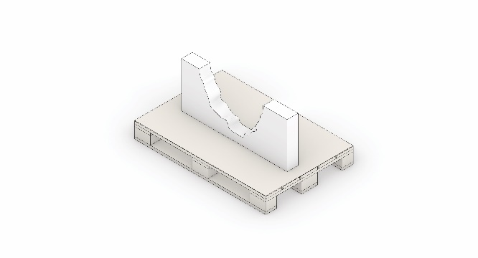

In this step, the broken building element is selected and stationed.

Step II

*Driving the mobile-robot to the building element*

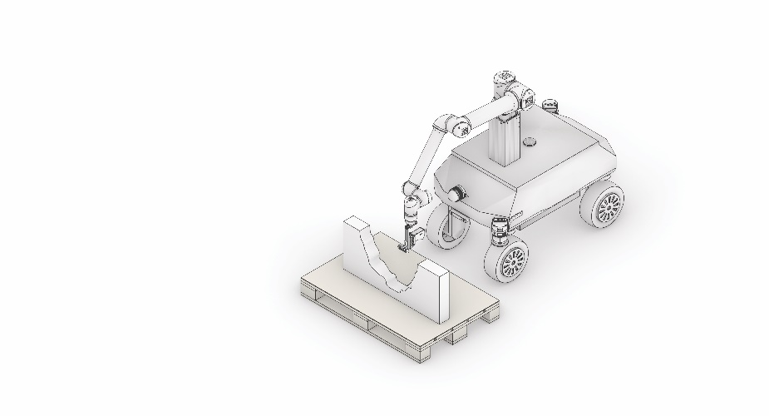

Here, a manual intervention is utilized to drive the mobile-robot near the selected object. The mobile robot will be equipped with an onboard camera-based sensing system to roughly recognize the geometric shape.

Step III

*Real Sense Positioning*

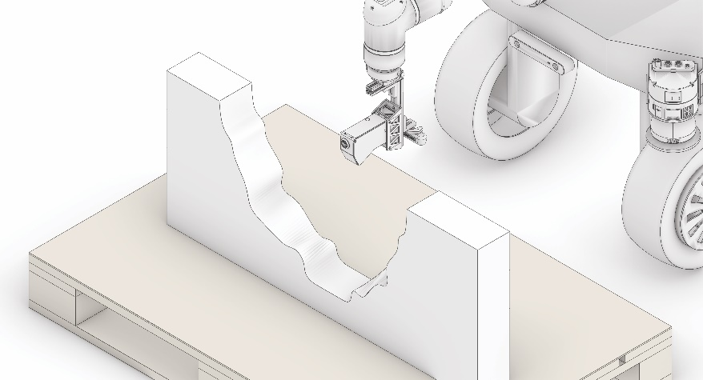

This step includes (manually) positioning and rotating the camera sensor ~~end-effector~~ in relation to the object to capture a proper field view for data collection.

Step IV

*Scanning Trajectory*

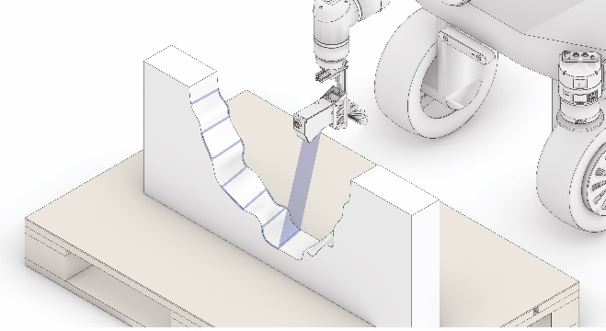

Here, identifying the exact area for refined laser-scanning from the camera image is conducted and overlayed with a zig-zag scanning path….

P.S not sure about the graphics here 😊

Step V

*Point Cloud Collection and Evaluation*

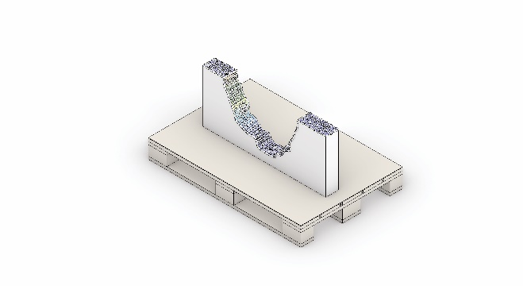

In this step, the point-clouds are ~~registered and~~ collected by moving the scanner along the predefined scanning path. Single scans are registered through transforming each line scan along the robot joints. ~~. These collected point clouds are evaluated using……~~

Step VI

*Geometry Re-construction*



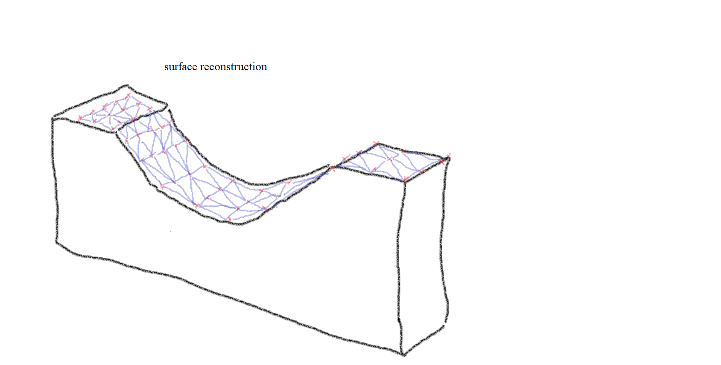

For further path-planning a closed surface is reconstructed based on the registerd point-cloud. Compensation of scanning errors is performed by ~80% subsampling of the intial data sets.

Step VII

*Printing Region Identifying*

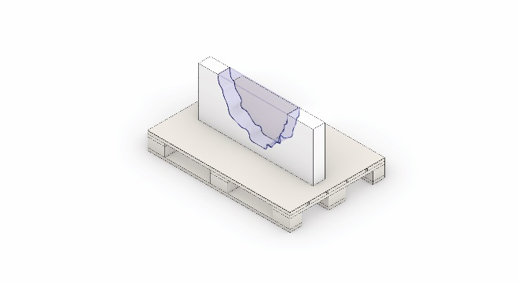

The reconstructed surface is utilized to trim the to-be-printed geometry.

Step VIII

*Printing Path Design Generation*

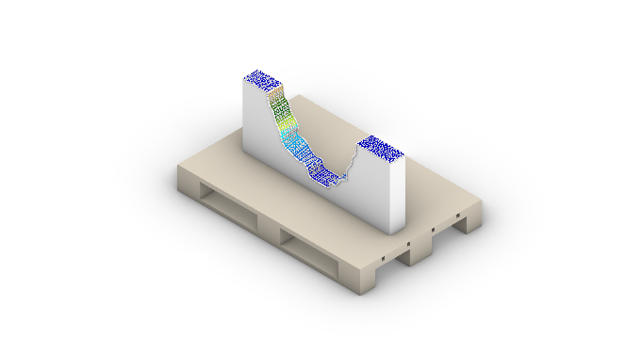

(in-progress)

Step IX

*Path Print Simulation*

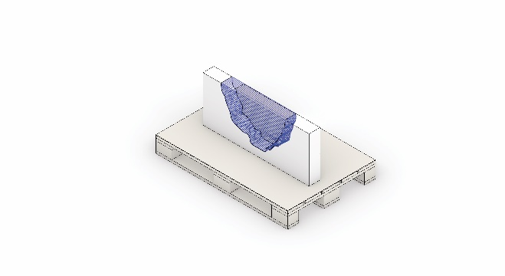

The printing path is simulated visually and it’s executed from the generated revAMp design.

Step X

*Extrusion 3D Printing*

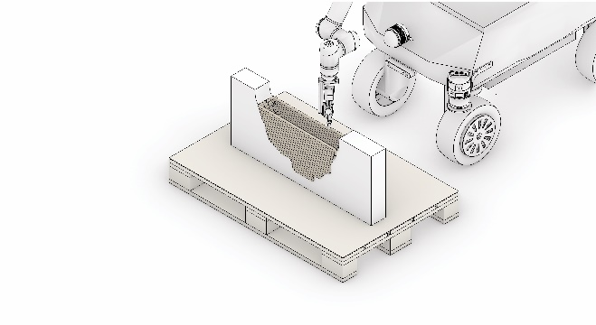

In this step, the mobile-robot will be equipped with an extrusion end-effector for the 3D Printing Process. The extrusion 3D Printing Process with clay has been developed in previous research projects and its controlled parameter such as (speed, distance from the surface, start and stop function,…) will be implemented.